Kahikatea Stationery list 2024 - Room 7

This year we are partnering with Warehouse Stationery, who will donate a $20 voucher to the school for every 5 packs bought.

They have all stationery packs ready for you to pick up in the Nelson store (at The Warehouse)

or you can order online at www.warehousestationery.co.nz
Select ‘Lists’, then search ‘Nelson Central School’ and select the Room number.

If ordering online, you can delete items you already have from the list or add any individual items as you like.
3 x 1I5 / 1WB (9mm ruled) exercise books (named)  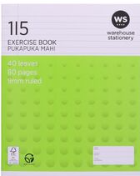  1 x Reading /Spelling  1 x Free Writing/Handwriting  1 x Writing | 1 x My Maths quad Book (named)  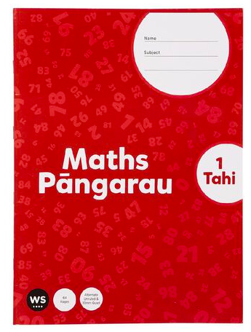 | 1 x Topic Book (named)  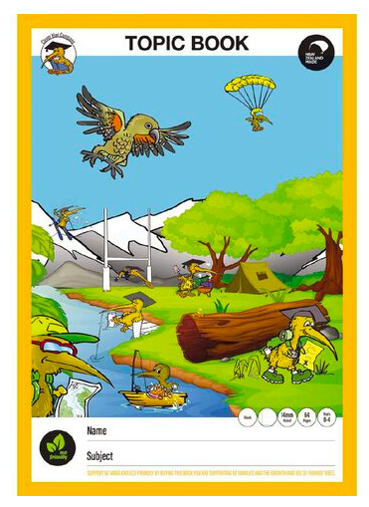 | 1 x headphones - these do not need to be flash or top of the line. (named)  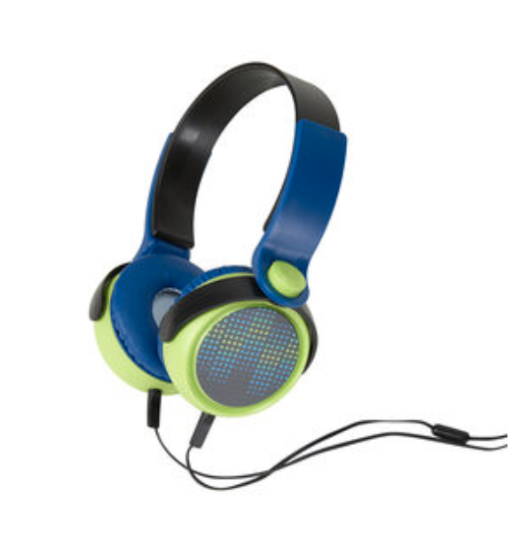
3 x Large AMOS Glue Sticks (named)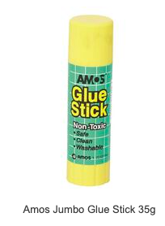 | 6 x HB Pencils  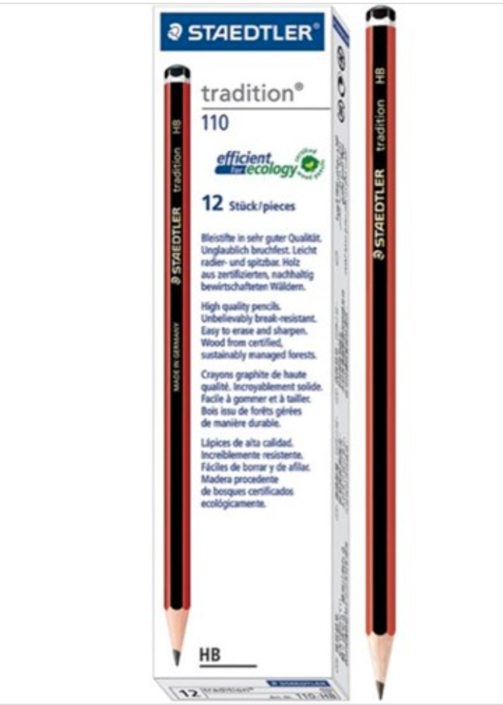 | 2 x Rubbers (named)  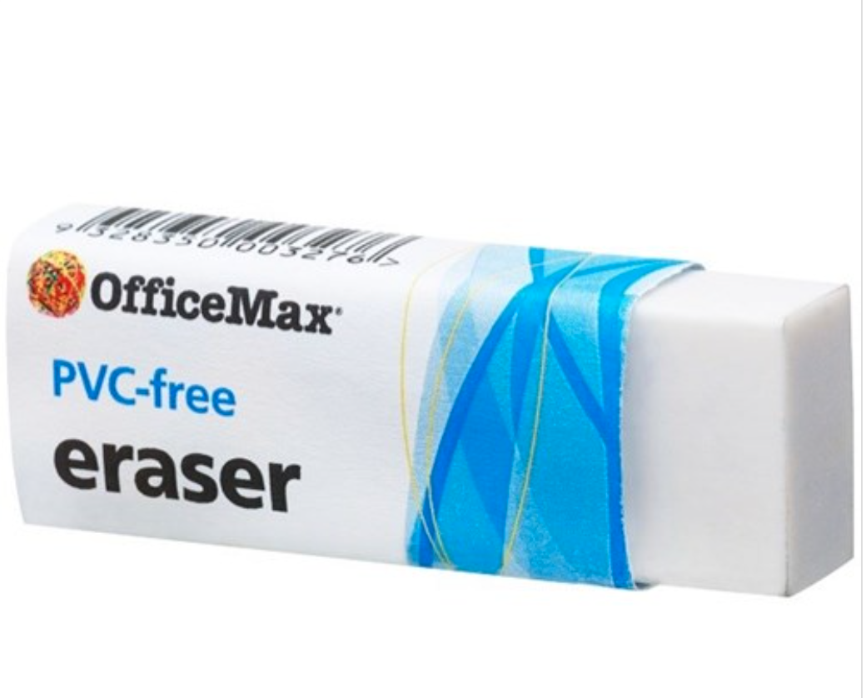 | 1 x small named pencil case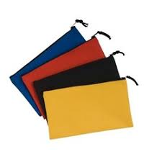
1 x Ruler (named)  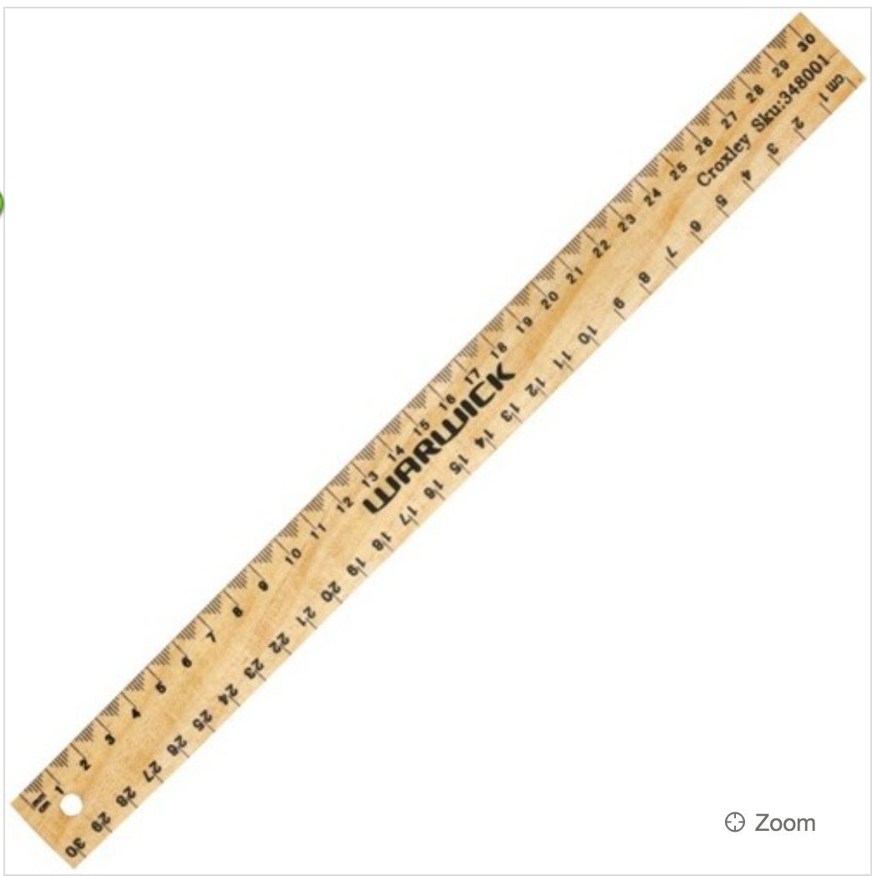 | 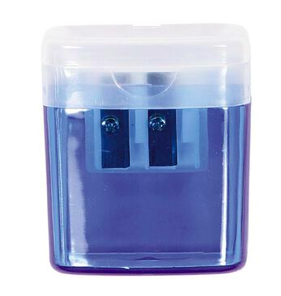  1 x Pencil sharpener (named) | 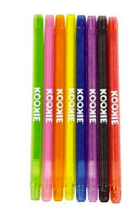  1 x pkt of twistable crayons (hello banana etc have some cheap one’s) (named) | 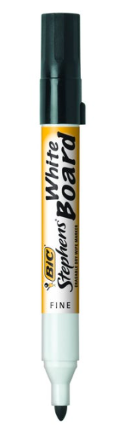  3 x Black Whiteboard Markers

