Kōwhai Stationery list 2024 - Room 11

This year we are partnering with Warehouse Stationery, who will donate a $20 voucher to the school for every 5 packs bought.

They have all stationery packs ready for you to pick up in the Nelson store (at The Warehouse)

or you can order online at www.warehousestationery.co.nz
Select ‘Lists’, then search ‘Nelson Central School’ and select the Room number.

If ordering online, you can delete items you already have from the list or add any individual items as you like.

 | 1 x Black Sharpie Markers  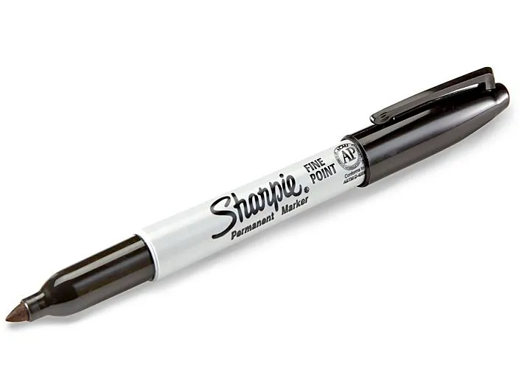 | 4 x HB writing pencils and 1 eraser  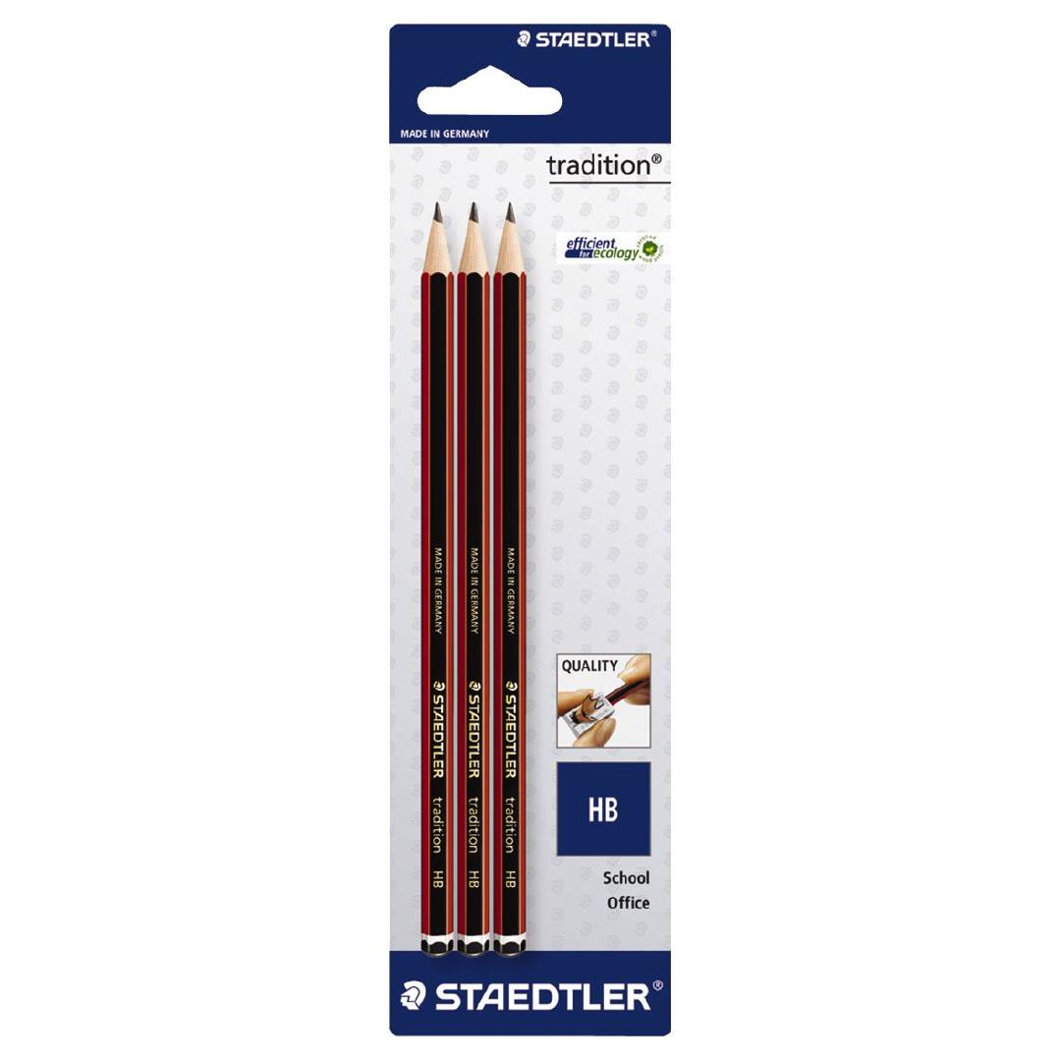 | 1 x LWB Handwriting book  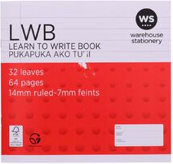
1 pack of colouring pencils  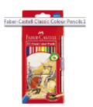 | 4 x Scrap Book - BLANK  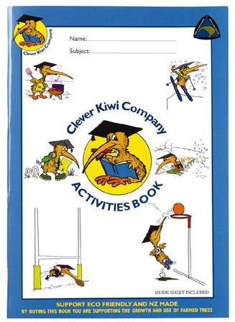 | 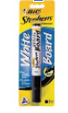  2 x whiteboard Markers | 2 x Glue sticks/ 1 roll of masking tape  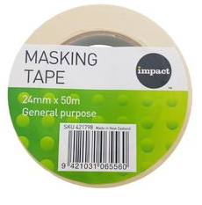
1 x 1A5 (Blank) book  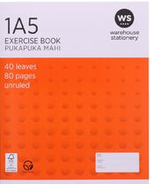 | 2 x 1F4 writing Book  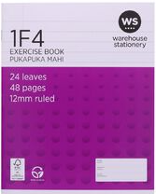 | School Hat $16  (new to school only)  (From school office) | 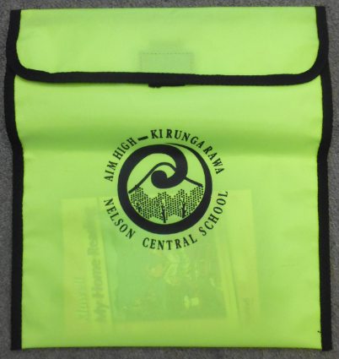  Homepack  (new to school only)  (From school office)

