Kōwhai Stationery list 2024 - Room 9

This year we are partnering with Warehouse Stationery, who will donate a $20 voucher to the school for every 5 packs bought.

They have all stationery packs ready for you to pick up in the Nelson store (at The Warehouse)

or you can order online at www.warehousestationery.co.nz
Select ‘Lists’, then search ‘Nelson Central School’ and select the Room number.

If ordering online, you can delete items you already have from the list or add any individual items as you like.
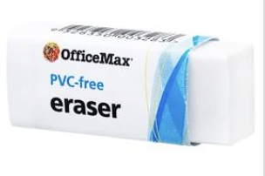  1 Eraser and 1 pencil sharpener | 4 x whiteboard Markers  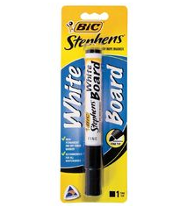 | 1 x 1A5 (Blank) book  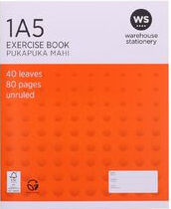 | 3 AMOS glue sticks
2 x 1F4 writing Book  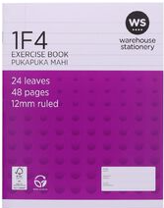 | 6 HB writing pencils | 1 x Black Sharpie Markers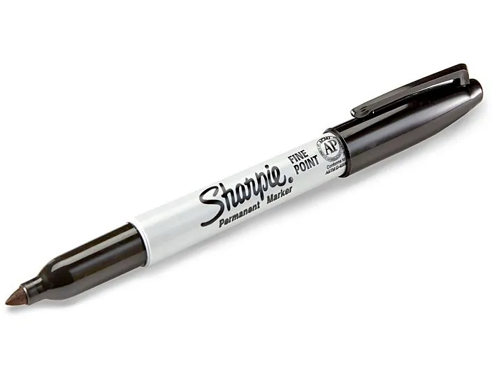 | 1 x LWB Handwriting book  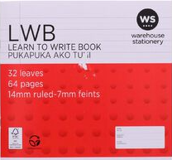
2 x roll of masking tape  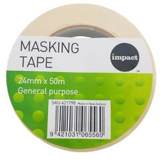 | 4 x Scrapbook - BLANK  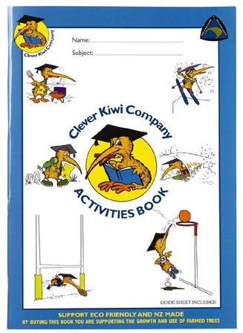 | 1 pack of colouring pencils  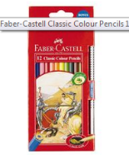 | 1x tissues  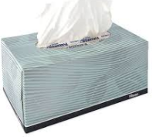
From School Office
School Hat $16 (new to school only) Homepack (new to school only)
