Stationery list 2024 - Te Pouahi tau 0,1,2

This year we are partnering with Warehouse Stationery, who will donate a $20 voucher to the school for every 5 packs bought.

They have all stationery packs ready for you to pick up in the Nelson store (at The Warehouse)

or you can order online at www.warehousestationery.co.nz
Select ‘Lists’, then search ‘Nelson Central School’ and select the Room number.

If ordering online, you can delete items you already have from the list or add any individual items as you like.

2 x pehea ā tuhi  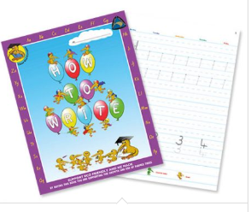  (new tamariki only) | 2 x pukapuka tuhi  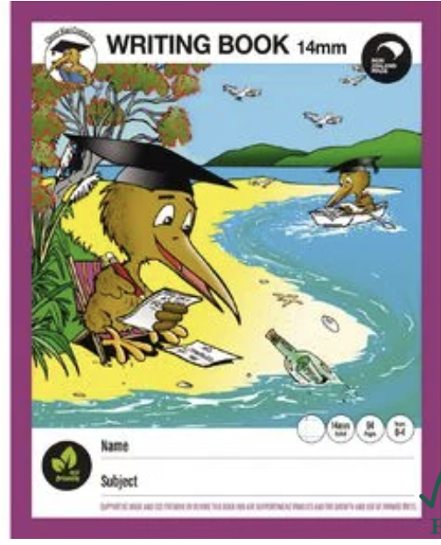  12mm and 14mm | 1 x pukapuka nui a mahi | 1x pukapuka iti  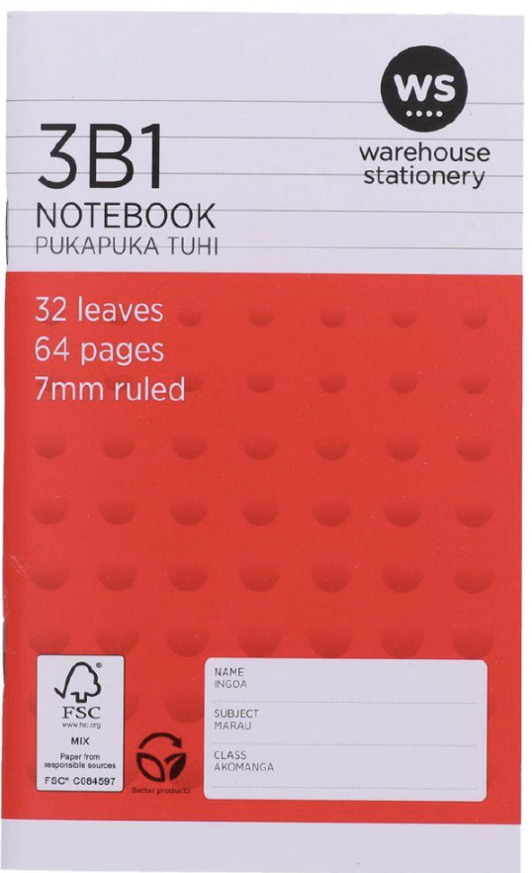
2 x pukapuka pāngarau  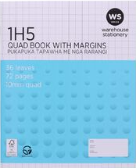 | 1 x Clearfile – 20 (new tamariki only) | 4 x hb pene rākau (without eraser)  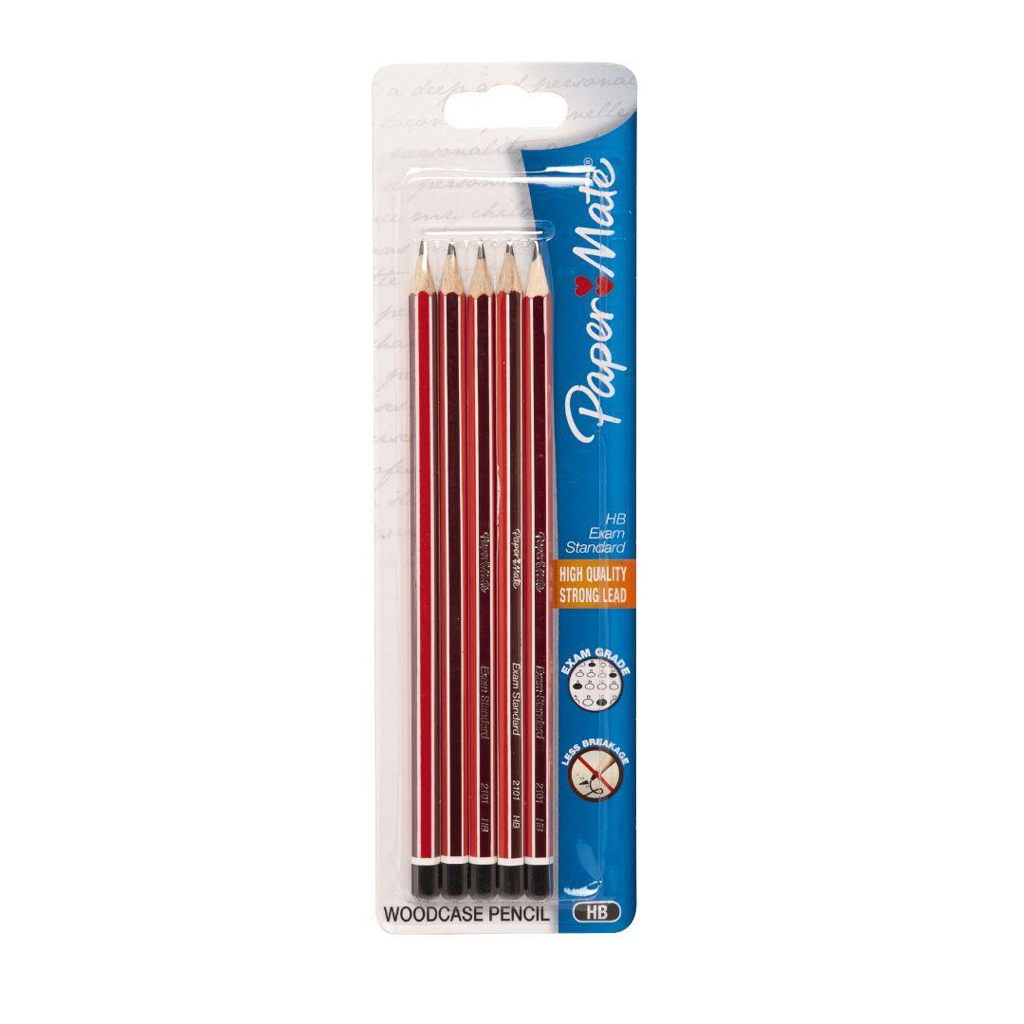 | 4 x pene papamā  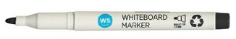
ine tau (not bendy)  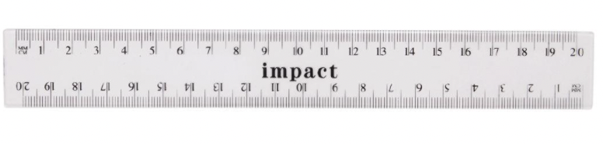 | 4 x BIC pene kahurangi | 1 ukui  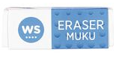 | 2 x rākau kapia
1 pencil sharpener  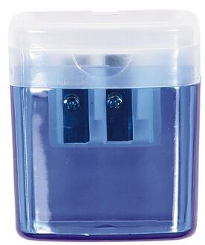 | 1 Kōpaki (new tamariki only)  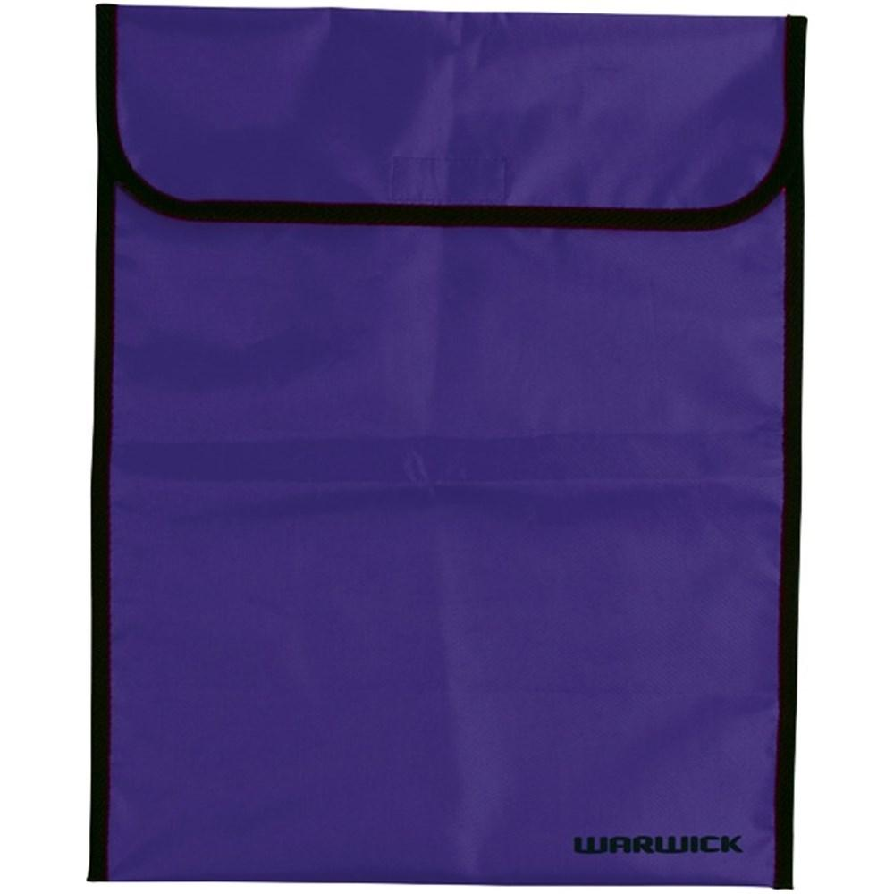 | 1 Pōtae (wide brim) (new  tamariki)  Can purchase from kura for $16.00

This year we are partnering with Warehouse Stationery, who will donate a $20 voucher to the school for every 5 packs bought.

They have all stationery packs ready for you to pick up in the Nelson store (at The Warehouse)

or you can order online at www.warehousestationery.co.nz
Select ‘Lists’, then search ‘Nelson Central School’ and select the Room number.

If ordering online, you can delete items you already have from the list or add any individual items as you like.

