Stationery list 2024 - Te Pouahi tau 3,4

This year we are partnering with Warehouse Stationery, who will donate a $20 voucher to the school for every 5 packs bought.

They have all stationery packs ready for you to pick up in the Nelson store (at The Warehouse)

or you can order online at www.warehousestationery.co.nz
Select ‘Lists’, then search ‘Nelson Central School’ and select the Room number.

If ordering online, you can delete items you already have from the list or add any individual items as you like.

1LWB5  4 x Writing Book  14mm Ruled  32 Leaves  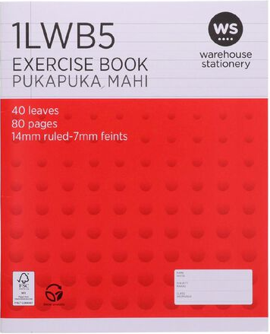 | 1H5  2x Maths Book  10mm Quad w/ margin  36 leaves  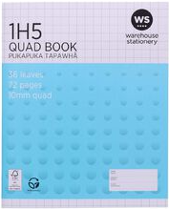 | Warwick No. 24  1x Project Book  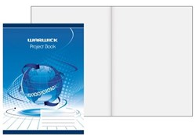  1x 3B1 notebook  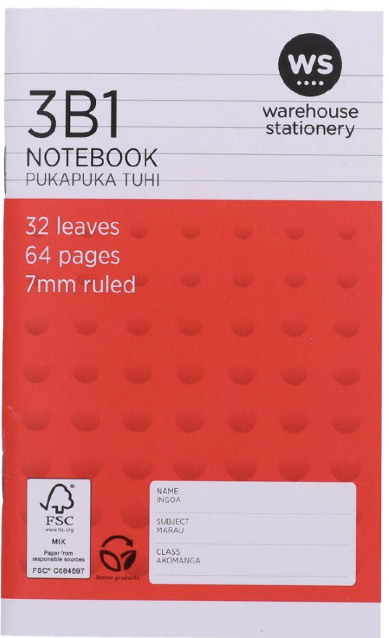 | BWB  1x handwriting book  14 mm Ruled  32 Leaves  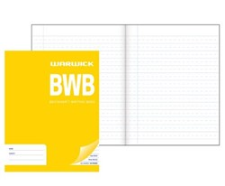
4 x HB pencils (without eraser)  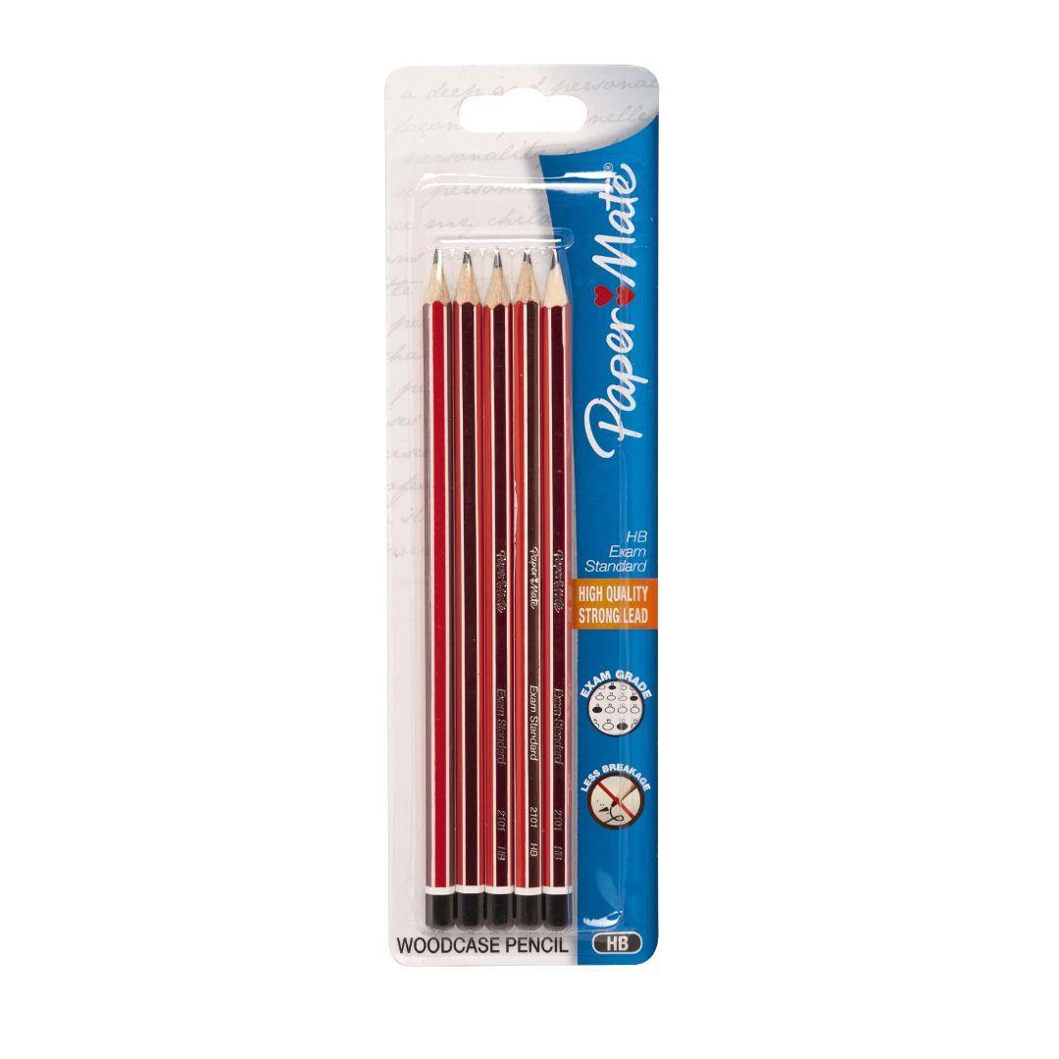 | 4 x whiteboard markers  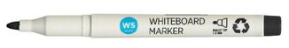 | 2 x glue sticks  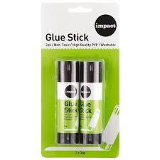  Please do not name | 4 x BIC pens – blue

